Partial Accomplishment Report

Thank you Augustinians!
On June 2015, we, the USA Student Council A.Y. 2014 – 2015, will formally end our one year term of serving the USA student body. Thus, we are glad to copy furnish you, our dear constituents, with our partial accomplishment report before the 2nd semester ends. We will be glad to entertain questions, comments, and suggestions during our STUDENT COUNCIL DIALOGUE which will be announced upon the approval of the VPAA. Thank you.

University of San Agustin
Gen. Luna St. Iloilo City
3/1/2015

RESEARCH AND DEVELOPMENT ADVOCACY

Conceptualized, initiated, authored, and financed more than 10,000 copies of the first University wide Augustinian Planner which (1) aims to assists the University of San Agustin in the K to 12 through a systematic visual support system that will facilitate successful referrals. (2) Assists the university in educating the students with useful information which was used during the recent PAASCU accreditation (3) Assists the Augustinians students, faculty, and staff with the pre-scheduled activities and important guidelines in school. The Office of the External and Alumni Relations office has also been distributing the planners to prospective students during their career talks all over Panay.

***

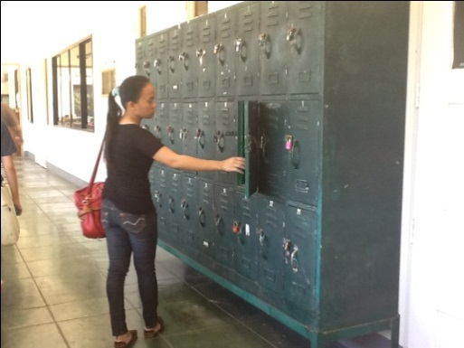

The USASC has successfully negotiated with the university administrators to provide more lockers for the Augustinians students. The five pager recommendation letter (plus the 32 pager exhibits attached) was already submitted and approved by the USA administration. The USASC will follow-up on the delivery of the said lockers this summer of A.Y. 2014-2015 after the potential locations, the number of locker units, and prospect suppliers are finalized.

***

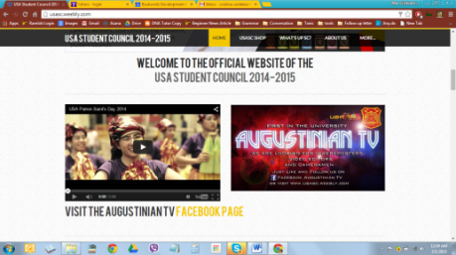

Facilitated the creation of the various facebook groups and USASC website that allowed effective and efficient online communication of USASC and USA admin related announcements. All facebook groups currently have 12,082 members in total and will hopefully become a useful tool in helping those who are in need of affordable school materials in the next academic school year.

***

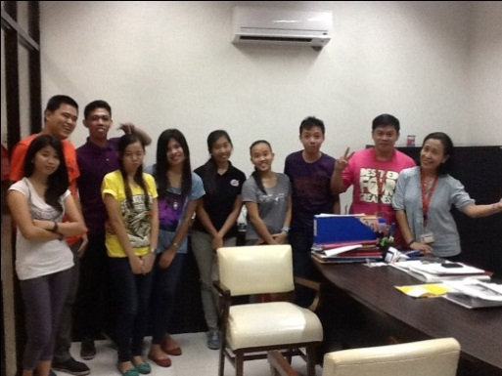

Submitted an eight (8) pager document proposal to the USA administration entitled “Convenience in the USA Enrollment Process” last summer of A.Y. 2013-2014 that suggested Customer relationship management, online enrollment systems, etc. Along with this is the manpower assistance provided by the USASC to the registrar’s office during the first semester enrollment purposely to help and study the operations in the registrar’s office – so as to make well-founded recommendations to the USA Administration. The insights gained from numerous dialogues made with the Augustinian student leaders and the experiential insights gained by the USASC were then communicated to the USA Administration during the committee meetings. The following, but not limited to, suggestions were made: creation of automated classroom scheduler (as featured in the President’s Courier), the decentralization of enrollment transactions, cutting down of bureaucracies in the requirements, credit card payment systems, etc. The result of this collaborative effort with the Committee was realized when the majority of the departments in the university finally started their classes ON TIME.

***

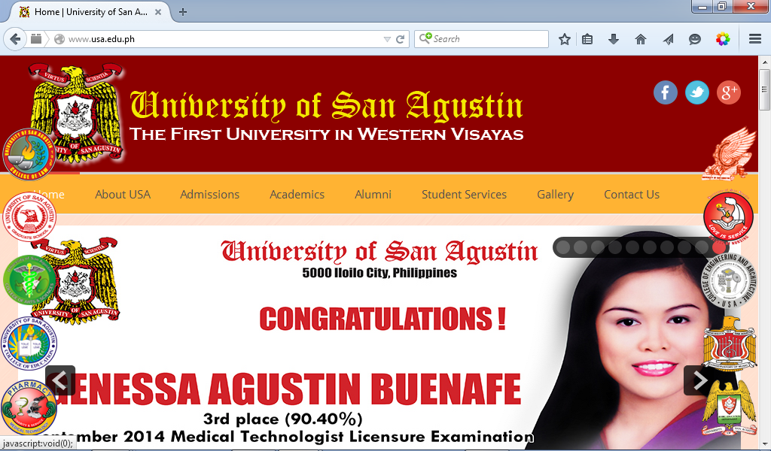

Assisted the USA Administration in the improvement of the University website by making content suggestions and by successfully referring a web developer that overhauled and improved the website of the university.

***

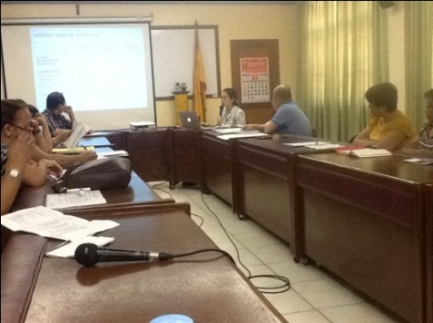

Supported the USA Administration in improving the various student facilities such as faster wifi (1GB internet speed) next academic school year and basic services such as a cleaner, safer, and free water to drink in school and most importantly in ensuring that the university will be attracting and retaining quality academic and non-academic personnel through improved compensation, performance, and retirement benefits.

AUGUSTINIAN MISSION AND FORMATION

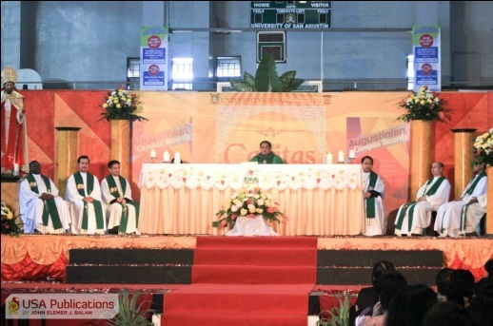

Collaborated with the USA Campus Ministry office during the University wide thanksgiving mass last February 12, 2015. The USASC initiated, financed, and designed the backdrop and petal decoration display at the USA Gymnasium.

***

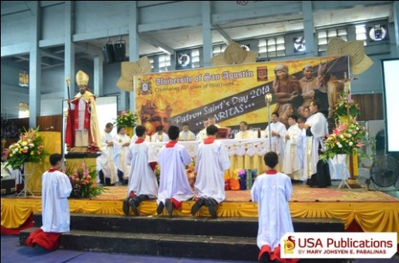

Collaborated with the USA Campus Ministry office during the University wide Patron Saint’s Day Mass held at the USA Gymnasium last August 29, 2014. The USASC designed the backdrop, financed the PSD bookmark production and distribution.

***
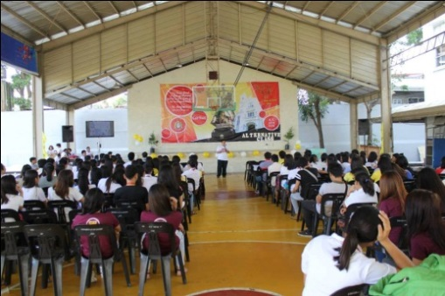

Initiated, co-sponsored, and collaborated with the USA Campus ministry, Pax Romana, and the In Deum group in facilitating the Alternative class on” the Papal Visit: A sharing of Experience, Reflections, and, Discussions” held at the USA Outside Courts during the University Week last February 12, 2015.

***

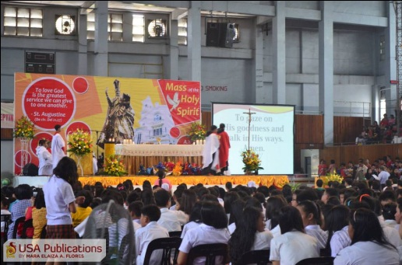

Designed the backdrop and collaborated with the USA campus ministry office during the University wide Mass of the Holy Spirit (Red Mass) held at the USA Gymnasium last June 18, 2014. The backdrop design was consistent with the design theme of the Augustinian planner, which was released in circulation a few weeks after.

***

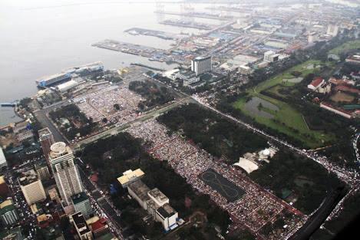

Initiated, organized, co-financed, and collaborated with the USA Campus Ministry, USA Office of the President, and USA Office of the USA General Services for the 2015 USA Papal Pilgrimage held in Manila. (The USA Papal delegates were also featured in the CBCP Monitor and in local newspapers, radio, and television programs)

***

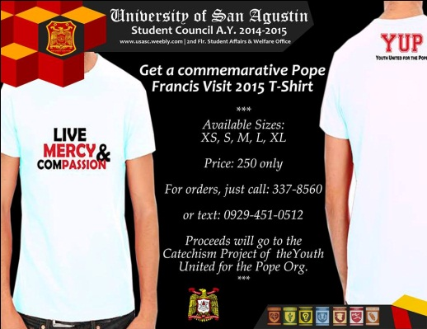

In partnership with the Youth United for the Pope and the USA Administration, the USASC facilitated the promotion of the various Papal merchandise in the campus.

***

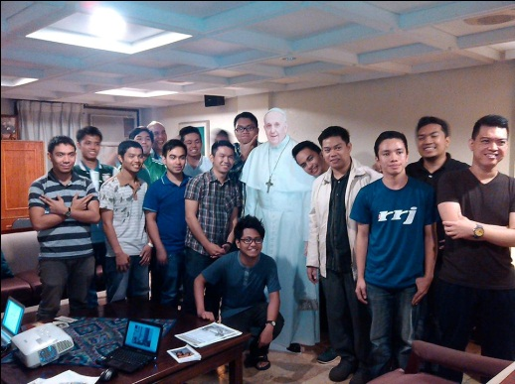

In partnership with the Youth United for the Pope, the USA Campus Ministry and the USASC facilitated the promotion of the Papal Standee, a project of Radyo Veritas and the CBCP. It was launched to encourage the people to take pictures with the Pope so as to increase awareness of the upcoming arrival of the Pontiff.
(Featured in CBCP and in various local media groups)

***

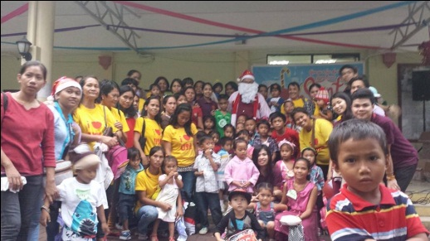

Initiated, facilitated, and financed the first Christmas party outreach with the parents and children of the Pacubas personnel and the USA adopted community - Brgy. Panusoon. The said event was held at the Herrera Hall of the University of San Agustin.

***

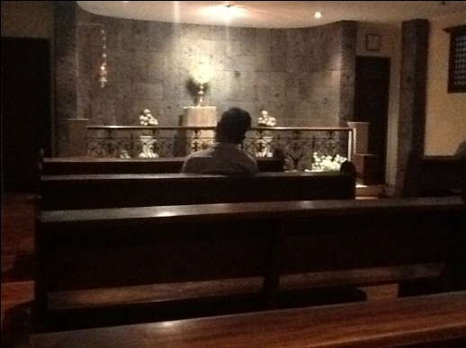

On the occasion of the 450th Year anniversary of the presence of Augustinians in the country, the USASC has submitted a proposal to the University President for the construction of a beautiful air-conditioned oratory to be constructed inside the University of San Agustin. This proposal was also supported by an external consultant of the university.

***

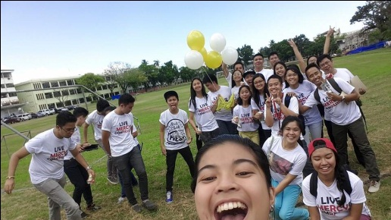

Founded the IN DEUM Group, from the popular term “In Deum” of the Augustinians, meaning “towards God,” is a youth organization in the university that is apostolic in its mission and vision to spread the message of Christ through Mercy and Compassion i.e. as inspired by the recent visit of the Holy Father, Pope Francis. Currently having more than 40 seed members, In Deum group is envisioned to lead future pilgrimages, initiate fun-filled apostolic activities and a vibrant prayer-life inside and outside the university.

***

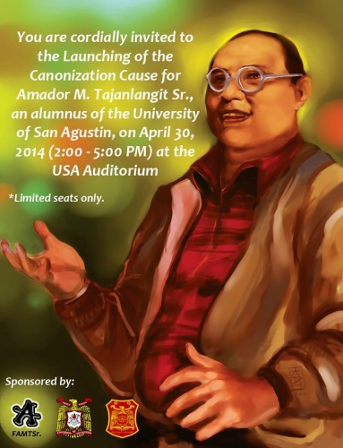

Supported and facilitated the launching of the first alumni candidate for sainthood of San Agustin-Iloilo last April 30, 2014 at the USA Auditorium. Tay Amador is known for his pious reputation of championing devotion to the Blessed Virgin Mary, the Holy Rosary, the Holy Eucharist, and solid Catholic doctrines. He has been an active preacher and had once lead the morning rosary program through the Radio station owned and operated by San Agustin-Iloilo. To date, many miracles have been attributed through his intercession and different groups from the Archdiocese of Jaro are propagating his cause for sainthood. (The event was featured in various local, national, and international tri-media groups including CBCP)

***

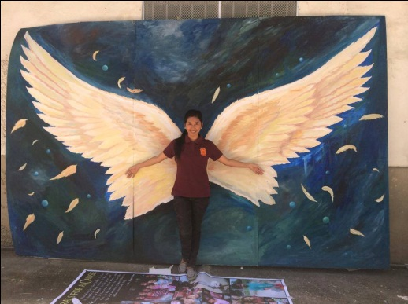

The USASC last Patron saint’s day, also initiated and financed the three (3) angel wing murals which was displayed adjacent to the USA cafeteria. Students, faculty, and staff were allowed to take photos and give donations for the benefit of the USA adopted community. The murals were donated to a school in Alimodian.

***

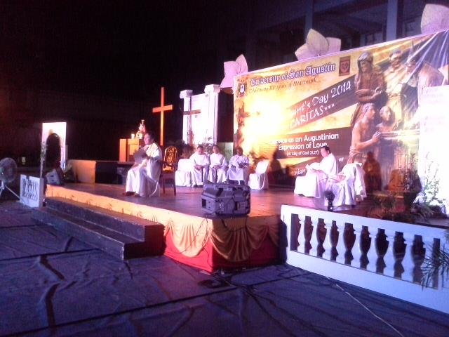

The USASC, with the collaboration of the college councils, also extended assistance to the USA campus Ministry through information dissemination, student attendance, and active participation in the Cassiciacum event held at the USA Gymnasium last August 29, 2014.

***

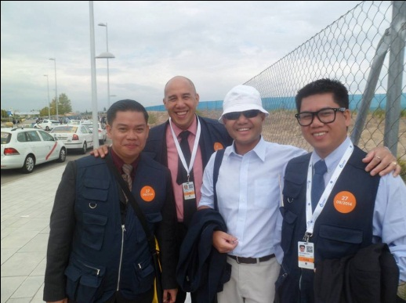

The USASC president represented the University of San Agustin as a Voluntario (Volunteer) in the Beatification of Bishop Alvaro del Portillo, the successor of St. Josemaria Escriva de Balaguer (founder of Opus Dei) held at Valdebebas, Spain last September 27, 2014.
(The event was featured in various local, national, and international tri-media groups | This trip was financed through sponsorships and through personal expenses paid)

***
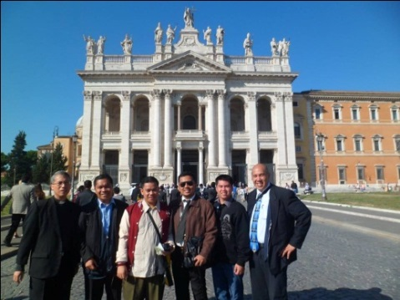

After Spain, the USASC president also represented the University of San Agustin and the Philippine delegates in the General audience with Pope Francis held at St. Peter’s square, Vatican City, last October 2014.
(The event was featured in various local, national, and international tri-media groups | This trip was financed through sponsorships and through personal expenses paid)

***

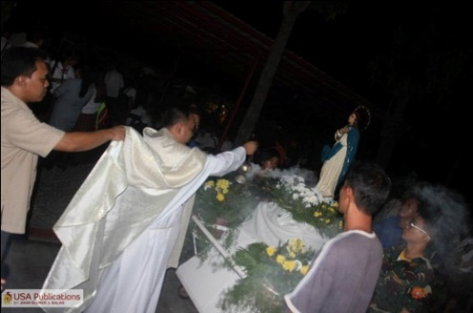

Co-sponsored the living Rosary program of the Pax Romana held at the USA quadrangle last December 8, 2014.

***

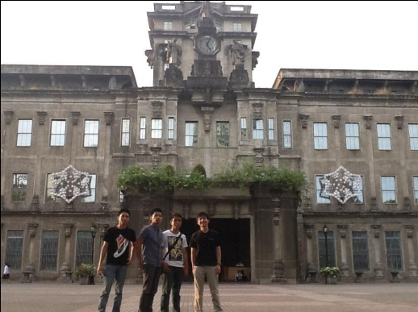

The USASC, through the initiative of the USA Campus ministry, has co-sponsored the alumni publication program of the Thomasian community.

***

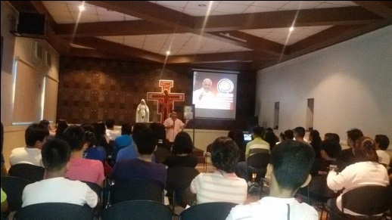

Participated in the Archdiocesan recollection, with other Ilonnggo delegates of the for the Papal visit at the Archbishop’s Palace last Jan. 18, 2015. (Featured in CBCP Monitor)

***

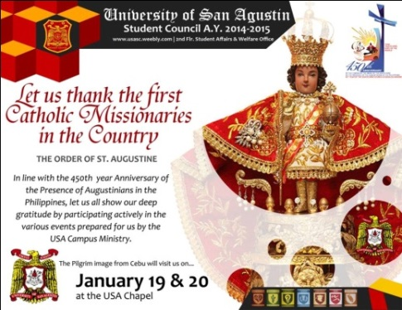
Assisted the USA Campus Ministry in making the Tarp Layout for the 450th Anniversary also in the promotion.

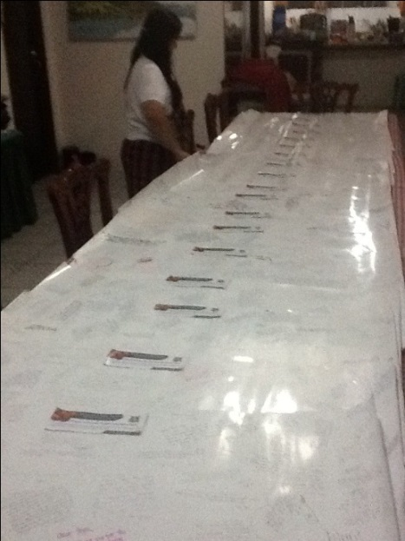

Collaborated with the USA main Library in facilitating and financing the collection of Papal prayer intentions for those who cannot come to the Papal visit pilgrimage.

***

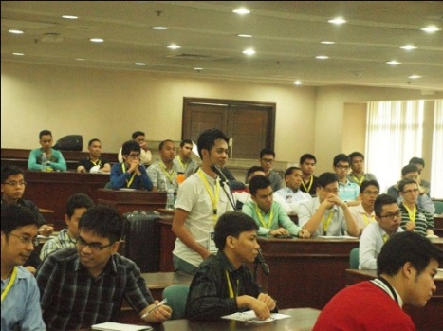

Participated and sponsored some Augustinian delegates to attend the “Gen Me to Gen We International Seminar” held at the University of Asia and the Pacific last January 17, 2015. The said seminar centered on the rationale behind the need to become a self-less leader, hence the term Gen We or Generation We instead of Generation Me (which refers to the much prevalent narcissistic or self-centered mentality). Other participants of the seminar included delegates from Taiwan, Singapore, and other ASEAN countries.

***

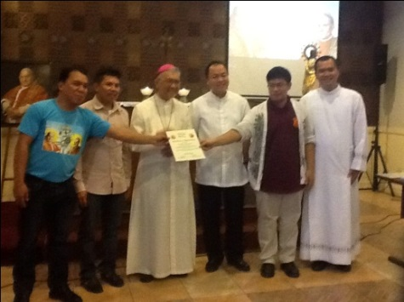

Helped the USA Campus Ministry in facilitating the relic visitation of Pope John Paul II, Pope John XXIII, and Blessed Ivan Merz in the University of San Agustin last May 22, 2014. The USASC President was recognized by the Archbishop Angel Lagdameo for this service.
(This event was featured in CBCP and in local tri-media groups)

***

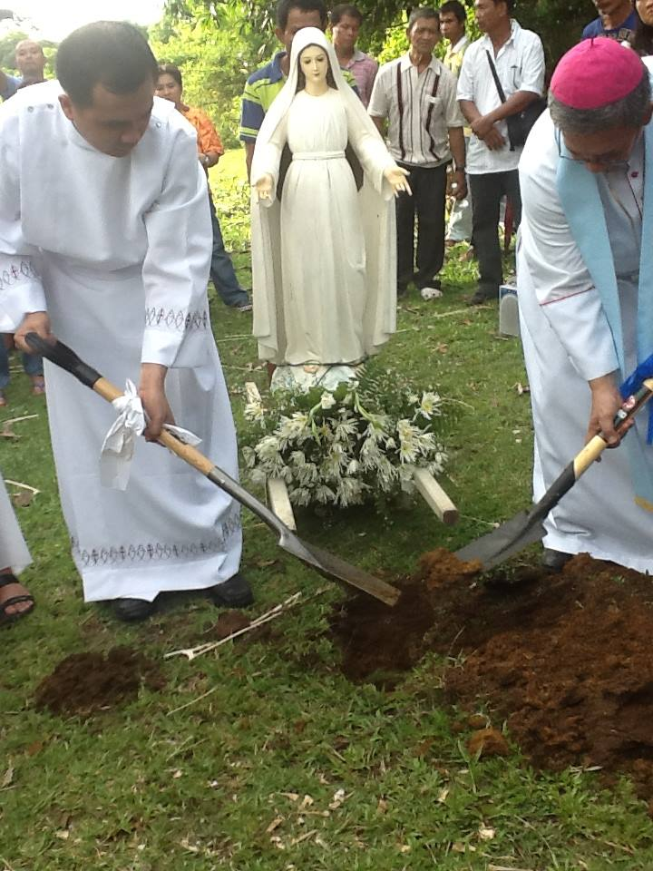

Participated in the ground breaking ceremony of the Mediatrix Retreat Center, a five (5) hectare land donation in Guimaras Island. The donation was made by a pious Ilongga who spents much of her time and effort spreading the message that Mary is a powerful intercessor for our prayer petitions.
(This event was featured in CBCP and other local tri-media groups)

ACADEMIC EXCELLENCE

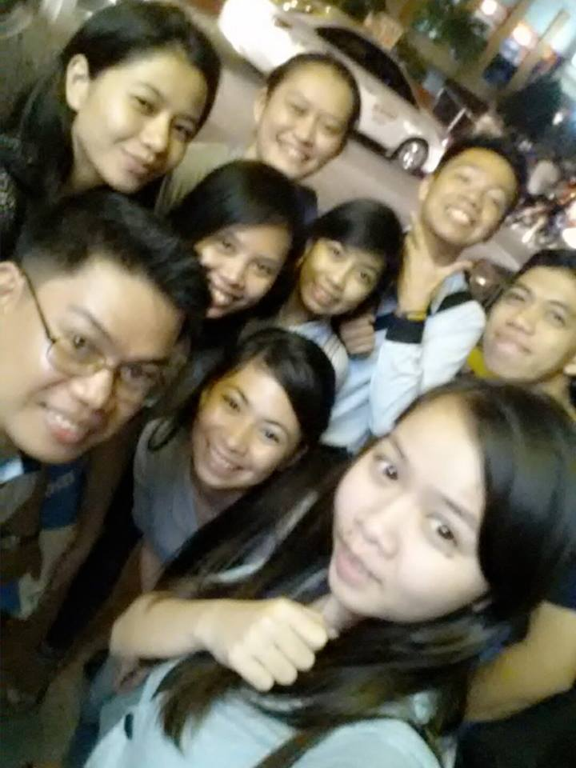

Last Patron Saint’s day, the USASC, in coordination with the Theology Department, has initiated, facilitated, and financed Augustinian Braniacs program that aimed to test the knowledge of the Augustinian community. The mechanics of the said program is to ask random students questions about information related to St. Augustine. The students who were able to answer correctly then receives a USA freebie such as ballers, key chains, etc.

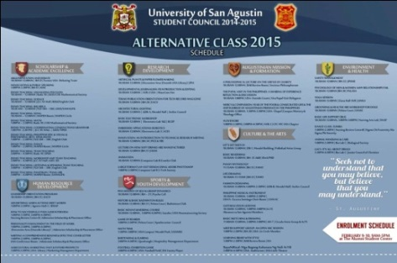

The USASC, in collaboration with various student, departmental, administrative, and outside organizations has simultaneously facilitated and promoted forty-six (46) alternative classes during the University Week. The said classes targeted the seven (7) Augustinian advocacies of the University.

***

The USASC, in partnership with Ms. Bibiana Uzoigwe of the College of Arts and Science has co-founded, Initiated and financed the Augustinian TV Project. As of December 2014, the USA Administration has approved the project proposal of the USASC and the Augustinian TV for procurement of new equipment (e.g. 2 DSLR Cameras, 2 Laptop computer, etc.) and regular funding assistance every semester for the operations of the Augustinian TV. The proposal included a studio proposal (which will also be used by the Masscom students), future programs that will be initiated, a plan to avail a cable channel slot for regular programming in the future, as well as expansion programs to Augustinian sister schools in the country and abroad.

***
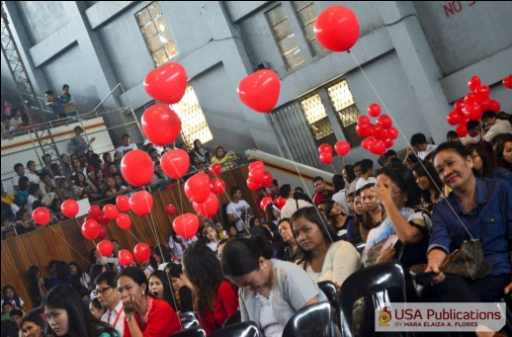

Pledged, as a major sponsor, in the “Raise to 110M: Building the University Brick by Brick” program of the USA Philanthropic Office. The said fund raising program is targeting to create a 110 million peso worth of trust fund that will sustainably finance the scholars of the university in the many years to come through the interest income produced by the said trust fund.
***

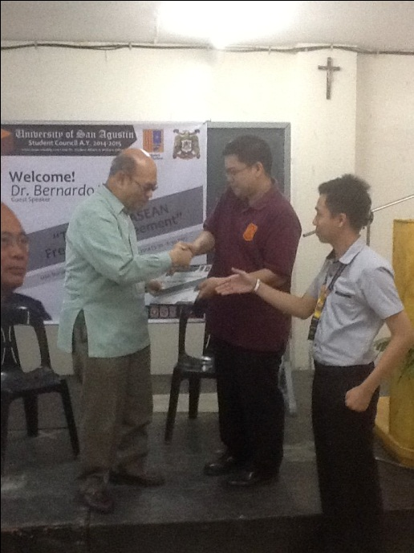

In partnership with the Institute for Values and Formation, the USASC sponsored and facilitated the Seminar on the ASEAN Integration by Mr. Bernardo Villegas. Dr. Villegas is a renowned economist here and abroad, a prolific author of many books which are used by many prestigious universities around the country, and he is also a formal presidential adviser during the late Cory Aquino. He explained in the seminar the effects of the ASEAN Integration to the country and to that effect, an insight on how the youth may benefit from it i.e. if properly equipped with the right mindset, skills, knowledge, etc. Held at the Nursing Review Center, the event was attended by more than 250 participants from San Agustin and some from other schools such as University of Iloilo, University of the Philippines, etc.

***

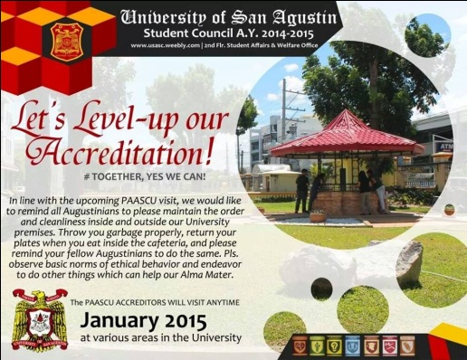
Assisted the university in the recent PAASCU visit through “year round” mass information dissemination of info-graphics (online and in-print) pertaining to the proper wearing of uniform, observance of cleanliness and proper decorum in the campus published through the USA planner, tarpaulins, etc. Prior to this, the USASC also formulated contest projects that will help the university level-up its accreditation. Among them are the Augustinian Model Office competition, the Eco-graphics competition, the Love Cup Challenge, various sustainable projects initiated and through proposal papers based on a field interview submitted to the Waste Management Committee of the University.

***

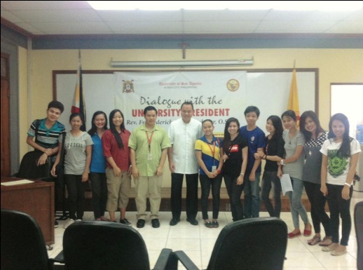
Successfully negotiated with the USA Administration to allow some students in the university to enroll despite their financial and academic set-backs. The USASC was also able to extend scholarship assistance to a deserving student of the university.
***

LEADERSHIP

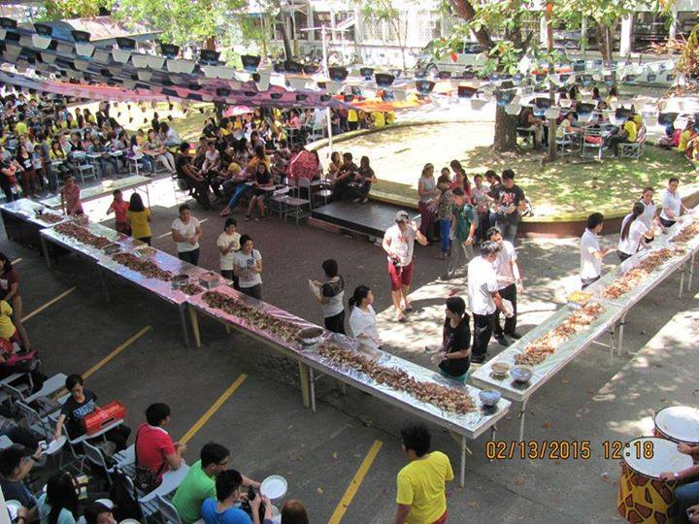
(Photo by: Mrs. Nelida Hernando)
Initiated the “Ground floor policy” in the annual University Week Salo-salo program. The idea is to ensure that everybody will see one another while eating lunch so as to foster friendship and camaraderie.

***

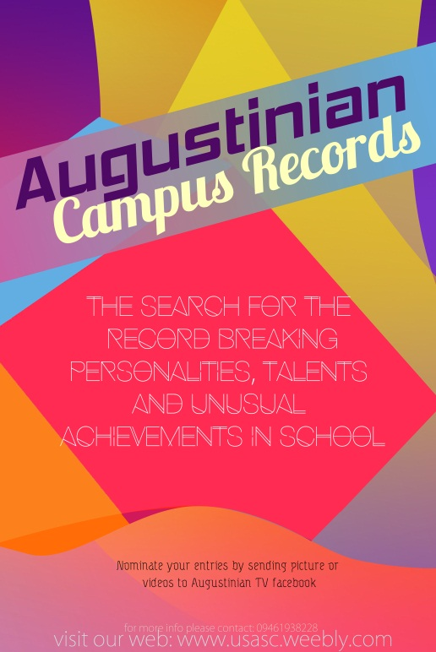

The USASC, in partnership with the Augustinian TV, the USA Publications, and the External and Alumni Relations Office, initiated and financed the university wide search for the record breaking personalities, talents, unusual achievements, as well as unique/noteworthy events in school. Dubbed the “Augustinian Campus Records”, the selected entries will be recognized and archived permanently in the university through the Augustinian TV and the USA Archives.

***

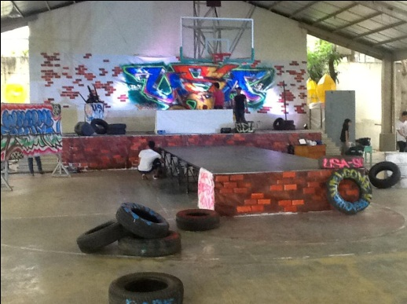

Facilitated and financed the 2014 Pang-abiabi or the Freshmen welcoming program of the University of San Agustin last June 19, 2014, which was participated by more than 1,600 freshmen students. The USASC was able to prepare a various programs such as an acquaintance party held at the outside courts and a salo-salo lunch held at various building venues, and a basketball game exhibition held at the University gymnasium.

***

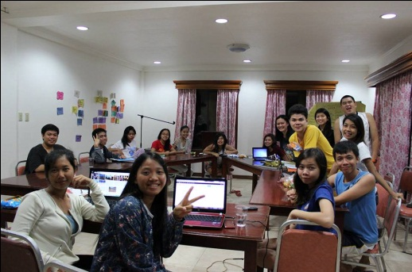

Last May 28 - May 31, 2014, the USASC conducted a four (4) day team building and planning session at Melrose Inland resort in Pototan. Facilitated by seasoned leaderhip trainors: Ms. Ramonita Pico, Mr. Eric Divinagracia, & Mr. Sunny Lasala; the USASC planned for projects and events for Academic School Year 2014 – 2015.

***

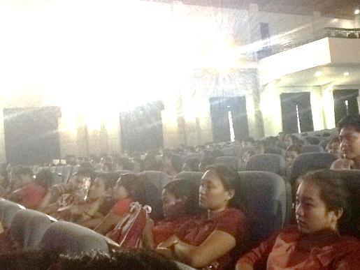

Facilitated the New Student Orientation (NSO) Seminar last June 18, 2014 (1:30 - 5:00 PM) at the USA Auditorium. The said seminar was divided into two (2) sessions to accommodate the Freshmen students who filled the USA Auditorium. The said seminar centered in encouraging the freshmen students to contribute to the Seven (7) Augustinian Advocacies of the University. The speakers for the said event was Rev. Fr. Williener Jack Luna O.S.A., Ms. Josefa Castro, Mr. Eric Divinagracia, Ms. Gian Bermudo, Mr. Demosthenes Toledo, and Ms. Deborah Panela.

***

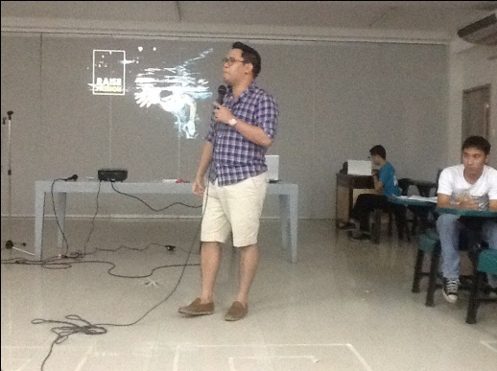

Last June 28, 2014, the USA Student Council as well as other student organizations attended the Business Model Canvass Workshop sponsored by the Student Affairs and Welfare Office. The said workshop inspired the student leaders to generate sustainable and purpose-driven projects in the University.

***

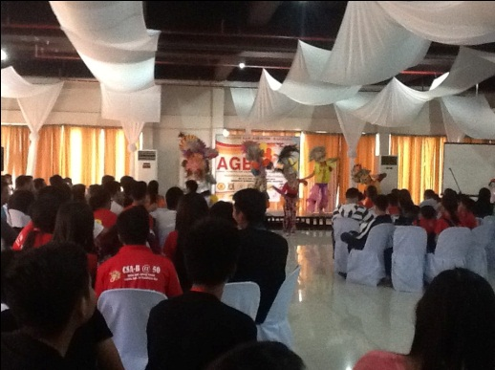

Participated and sent delegates to the 7th AGBAYAN series held at the NorthLand Resort in Manapla, Negros Occidental last July 25 to 27, 2014. It was attended by various delegates from other Augustinian sister schools coming from Iloilo, Bacolod, Manila, etc. The event fostered unity and camaraderie, and most of all, inspired many young Augustinians to become excellent and well-rounded leaders of their respective institutions.

***

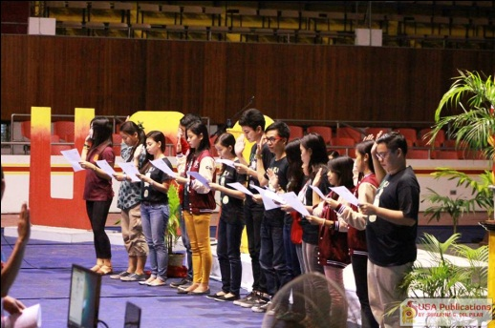

Participated and co-sponsored USA the Recognition day of Student Officers, members, and advisers held at the USA Gymnasium. The said event also featured the turnover ceremony of the previous USA Student Council and a showcase of Augustinian Passion projects pledged by every organization.

***

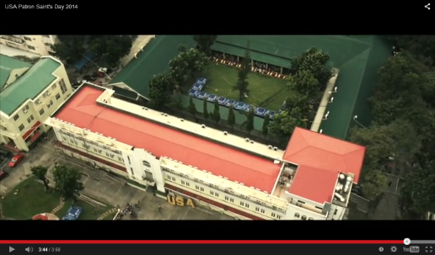

The USASC, in partnership with the External and Alumni Relations office, financed and initiated the first aerial drone technology video coverage in Western Visayas during the Patron Saint’s day celebration. The said video is currently used by the university in its Marketing and promotion efforts. During the university week, the same technology was used in order to cover the event highlights.

***

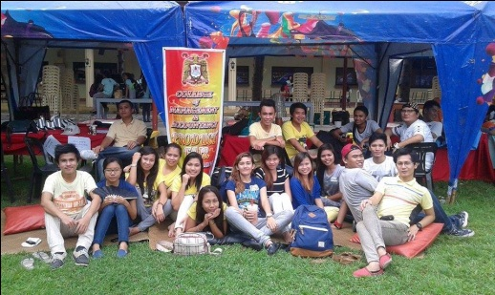

The USASC co-sponsored and co-facilitated the first product Fair of the 3rd Year Marketing Management Students of the College of Management and Accountancy. Held at the USA Quadrangle during the Patron Saint’s day, the said fair featured free product testing and exhibition.

***

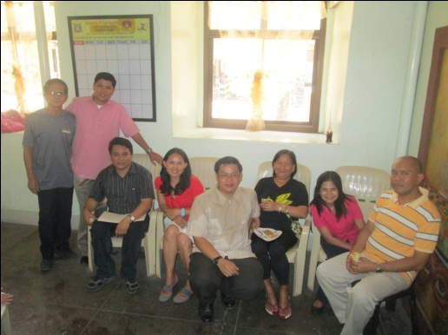

Co-financed the Pang-abiabi, Patron Saint’s day, and the University Week salo-salo which catered to hundreds of San Agustin academic and non-academic personnel such as the Pacubas, security guards, faculty and administrative staff of the university.

***

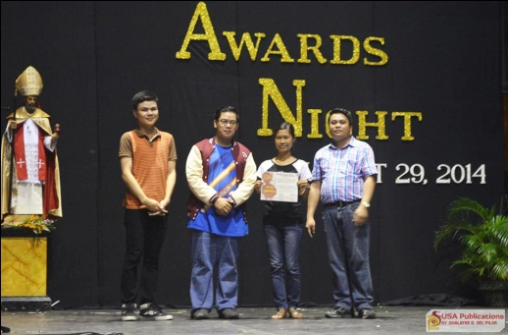

Last August 29, 2014, the USASC facilitated and financed the grand Augustinian Awards Night held at the USA Gymnasium last Patron Saint’s day. A barrio-fiesta food festival and a series of band exhibition (August Rush) featuring departmental, personal, and outside bands followed after the said event.
***

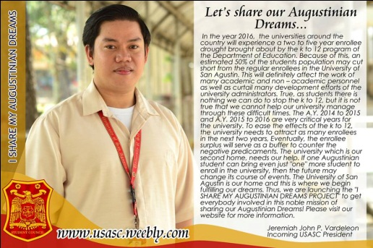

Initiated the “i share my Augustinian Dreams” project– which is a year-long campaign and initiative of the USASC to get all Augustinian students, faculty, staff, and even outsiders to get involved in the Marketing efforts of the university i.e. in preparation for the effects of K to 12 this 2016. The said project gave birth to initiatives such as various videos created to promote the university, the production of the Augustinian planner, the active participation of students to share various campaign materials of the university, the production of thousands of university memorabilia, as well as USASC events and contest purposely designed to generate positive publicity for the university.

***
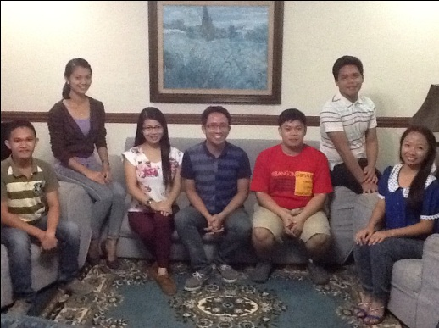

Dreaming big for the city and their respective universities, the Student Council presidents joined forces to draft the constitution of the first STUDENT COUNCIL ALLIANCE IN ILOILO CITY. The said alliance aims to generate a more robust and competitive inter-school events and collaborations through the Student councils in the city. Jeremiah John P. Vardeleon was elected as the Vice President for External Affairs of the said alliance group. The following schools framed the constitution and by-laws of the said alliance: Phinma Education - University of Iloilo, University of San Agustin, John B. lacson Foundation University, John B. Lacson Foundation Maritime University, Arevalo, West Visayas State University, Central Philippine University, the Western Institute of Technology, and other schools

***

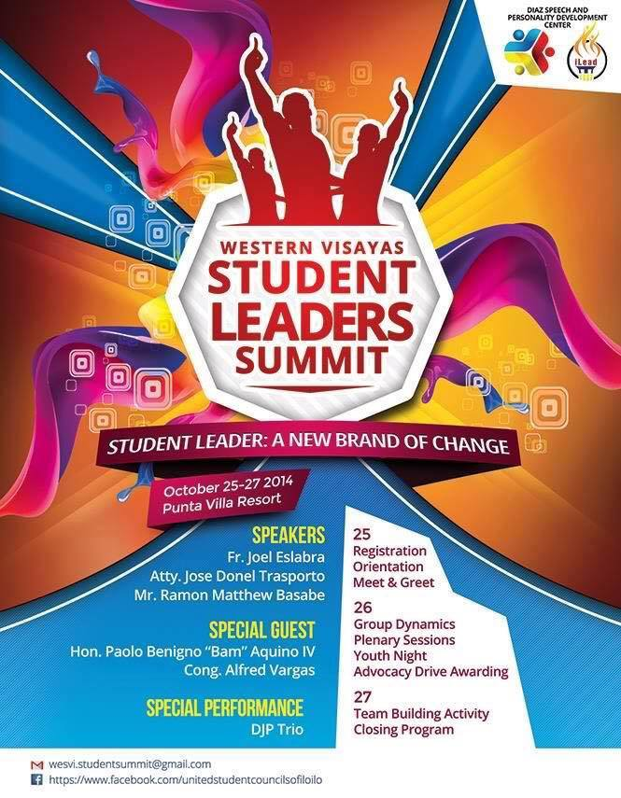

Participated in the Western Visayas Student Leaders Summit with the theme “Student Leader: a new brand of change” held at Punta Villa resort last October 25-27, 2014. Co-organized by the Student Council Alliance of Iloilo City, the said event had the following as resource speakers: Fr. Joel Eslabra, Atty. Jose Donel Transporto, Mr. Ramon Matthew Basabe, Hon. Paolo Benigno “Bam” Aquino IV, and Cong. Alfred Vargas.

***

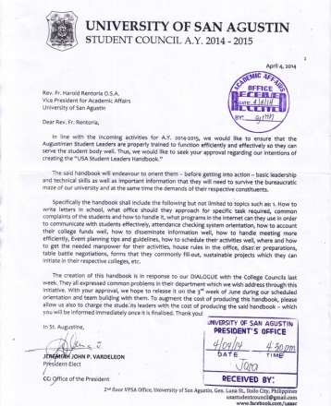

Submitted a proposal for the creation of the USA Leader’s Handbook. The said handbook is envisioned to orient the Augustinian Student Leaders – before getting them into action – basic leadership and technical skills as well as important information that they will need to handle effectively and efficiently the bureaucratic maze of our university and at the same time the demands of their respective constituents.

***

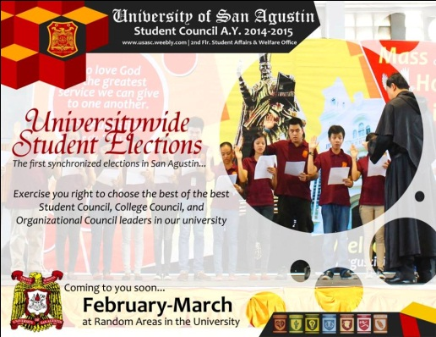

Financed the university wide Student Council elections for A.Y. 2015 – 2016 this March 2015 by funding the SCOMEL composed of the various college council presidents of the university. The fund will be used for the food and drinks of the volunteers as well as other operational expenses of SCOMEL.

***

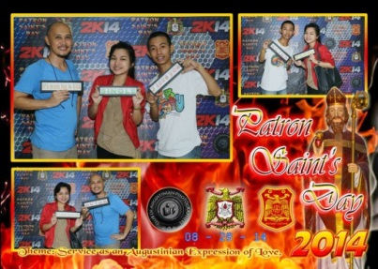

Assisted the Club of Augustinian Photographers in their income generating photo booth activity during the Patron Saint’s day celebration last August 29, 2014

***

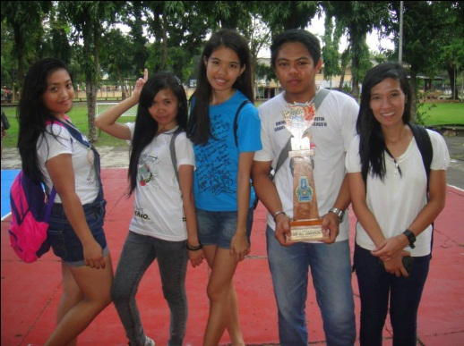

Extended financial support to the USAGIASA (working scholars of the university) in their recent ICSAA competition (an interschool competition of Grant-in-aid scholars) held at the West Visayas State University. The USASGIASA, under the leadership of Ms. Josa de Jesus, emerged as the champion in the said competition.

***

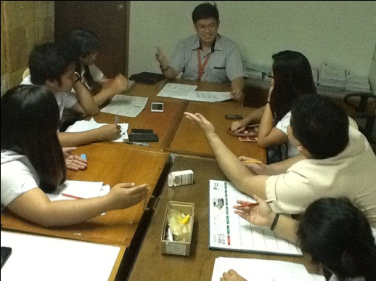
Conducted hundreds of meetings and dialogues with the previous and incumbent Student leaders of the university, the USA administration, the ordinary students, faculty, staff, suppliers, non-academic personnel, etc. The said meeting consisted of coordinating activities, concerns, suggestions, and the like which was transformed by the USASC into action through policies and sustainable programs.

ENVIRONMENT AND HEALTH

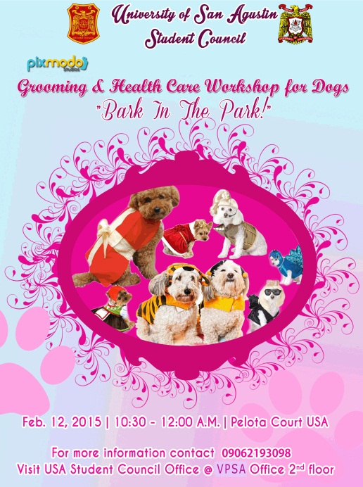

Organized and financed the “Grooming and Healthcare” Workshop for Dogs, an alternative class facilitated directly by the USA Student Council during the University Week celebration.

***
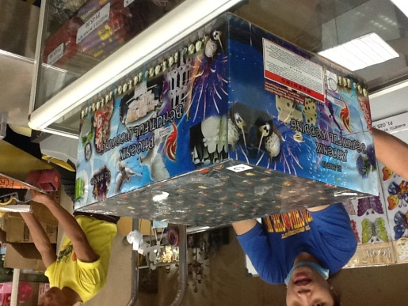
As part of the environmental-friendly program of the university, the USASC implemented a year-round “minimal fireworks display policy” as a way for the Augustinian community to contribute to this university effort of protecting our environment. “Gunpowder fuels the flight of fireworks while metallic compounds give them their flamboyant colors. Though a pretty sight, they can have ugly effects on the environment because these toxics find their way into bodies of water, making them acidic. They end up in the soil, depleting its nutrients and possibly poisoning animals, plants and other organisms. Consequently, these chemicals also cause a lot of lung problems.” – Rappler.com

***

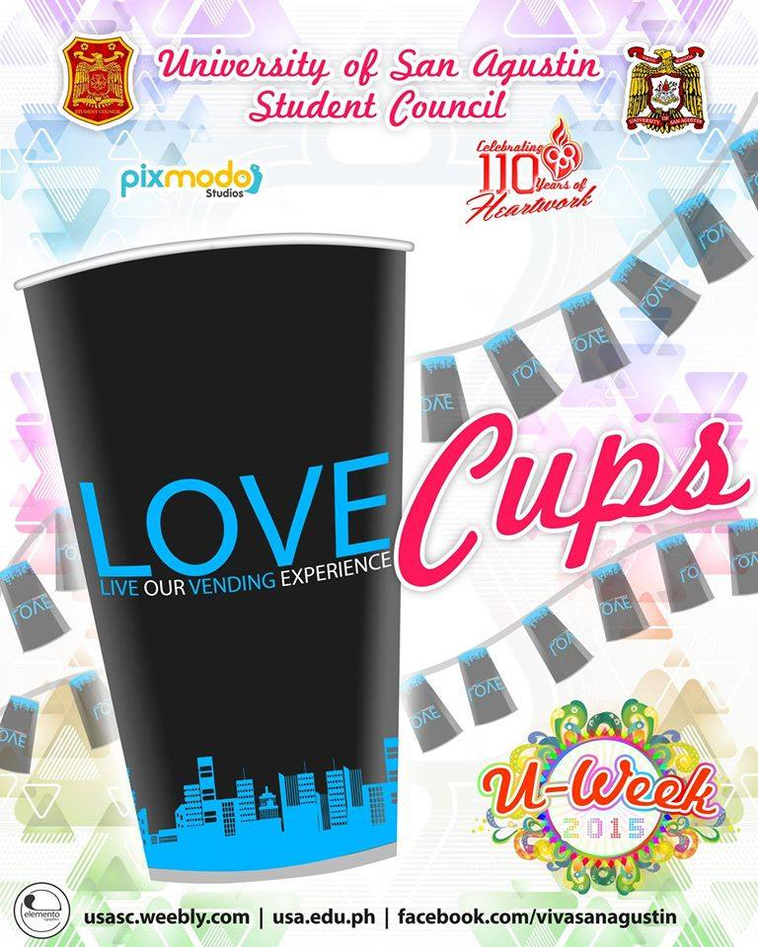

Conceptualized, initiated, and financed the first love-cup challenge competition. This contest was created to motivate the Augustinian students to collect love cups for a period of eight (8) months and turn it into creative “banderitas” during the University week celebration. The contest was in response to the request of the USA Administration that the USASC provide assistance in managing the love cups scattering around the campus at the first two months of the start of classes. According to the USA Waste Management Committee, many of the decorated love cups will be donated to public schools for future use.

***

The USASC has developed the eco-graphics contest in order to facilitate public awareness in the San Agustin campus through creative info-graphics that will inspire the students to participate in the order and cleanliness drive of the USA Waste Management Committee. This project was inspired by a study revealed by the Center for Applied Research of the University of Missouri, they concluded that “A successful method to any waste management effort is to make the public aware of waste management issues so they will understand the consequences of improper management of waste and how it may ultimately pose a serious threat to their lives and well-being.”

***

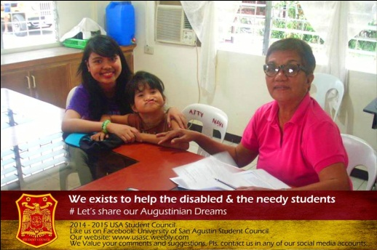

Endorse the submission of the fifteen pager project proposal dubbed “PAGLAUM” for the disabled students, faculty, and staff to the university President as proposed by Ms. Deborah Panela. Indicated in the said document are request for ramps, appropriate signages, fully functional elevators for the disabled, and the creation of a specialized organization – dubbed PAGLAUM - that will compose all the disabled students in the university. The said organization will enjoy special privileges in the campus according to the said proposal.

***

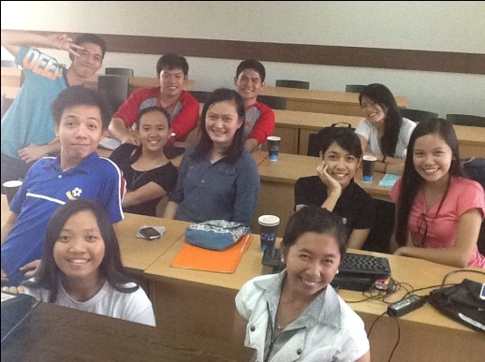

Submitted the 2 pager proposal to create a “Boarding House Accreditation Program” for the University in order to assists the Augustinian students and their guardians to conveniently find proximate and conducive boarding houses within their budget. This project is envisioned to allow the university to demand a good standard of security; clean and drinkable water, well maintained rest rooms, bed rooms, study rooms, and require the home owners to attend continuing seminars such as how to deliver quality services to their borders and how to observance collection etiquette.

***

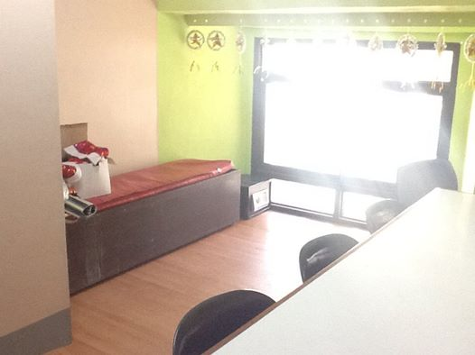

The incumbent USASC has successfully negotiated with the USA Administration for the expansion of the current USA Student Council Office by roughly 150% increase in floor area. The office expansion was then followed by a series of office renovation such as repainting and application of durable floor wood linoleum – that will last for many years to come. In addition to this, the USASC was also able to purchase a high lumen Epson projector and a brand new continuous ink Canon printer which will be used by the future student councils.

***

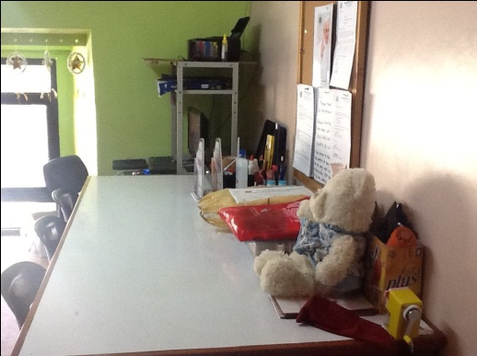

The USASC in partnership with the USA Waste Management Committee has initiated, formulated, financed, and facilitated the first search for the Model Augustinian Office that facilitated observance of good office ergonomics in the campus. The said competition considered the following: Waste management, noise reduction and management, reduction of electrical consumption, proper physical arrangement, reduction of visual pollution, customer relationship management, and proper ventilation. Last Patron saint’s day, the said competition was participated by various student organizations, dean and faculty offices in the campus. The USA administration has expressed their support in making this competition an annual event with the participation of the administrative offices of San Agustin Main and Sambag Campus.

***

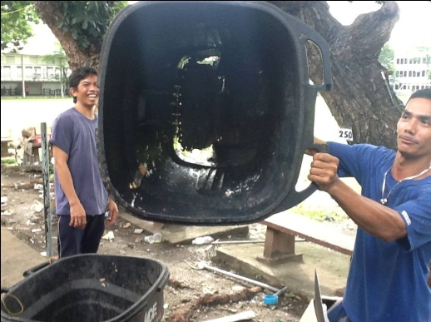

The USASC also submitted a proposal to the USA Waste Management Committee by collecting waste management suggestions from the Pacubas, the students, and other concerned Augustinians in the campus. Among the recommendations made are the following: installation of vendo machines that will provide soap, sanitary napkins and tissue papers for the students; replacement of old trash bins; and other waste management procedures.

***

SPORTS

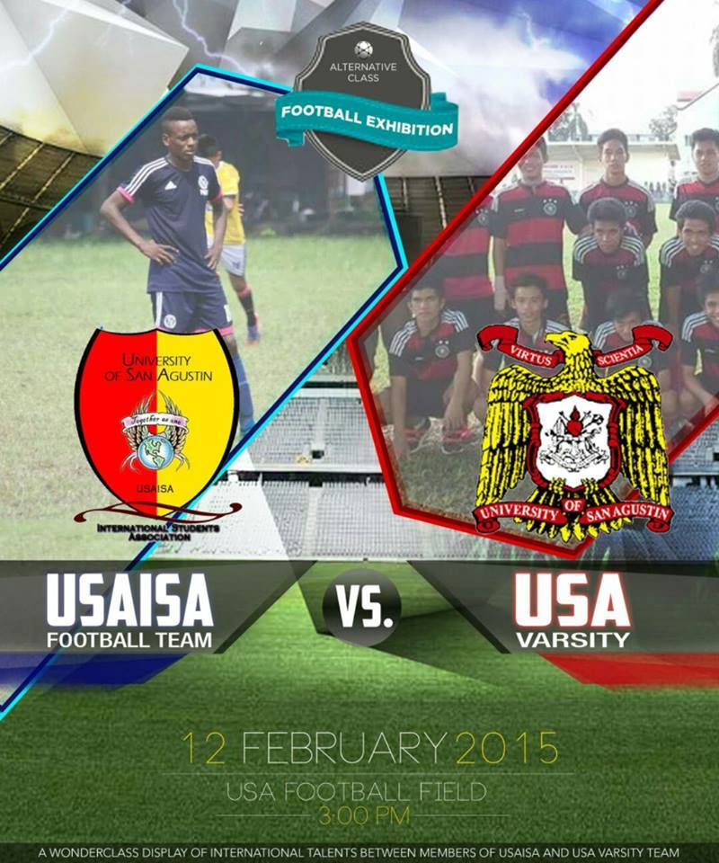

The USASC financed the Football Exhibition between the USA International Students Association and the USA Varsity Team during the University week celebration last February 12, 2015 held at the USA Football field.

***

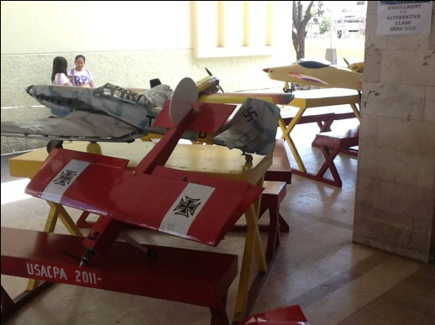

The USASC facilitated and financed the miniature airplane display and aerial exhibition dubbed “Toys for the Big Boys” during the University Week celebration.

***

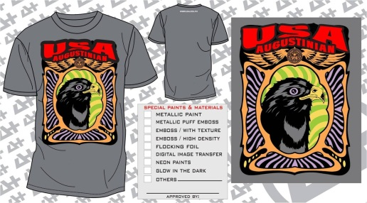

The USASC also co-sponsored the university t-shirts of the USA Varsity Players through the sports office.

***

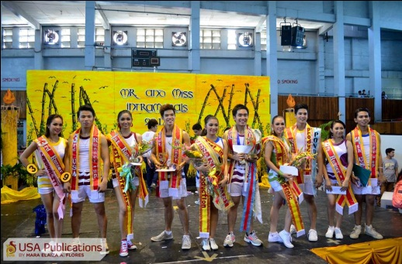

The USASC, in collaboration with the P.E. department, co-sponsored and co-facilitated the Ms. And Ms. Intramurals 2014 during the pre-patron saint’s day celebration.

***

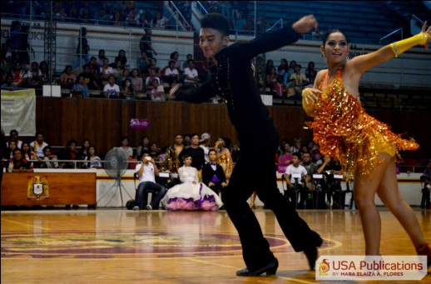

The USASC, through the P.E. Department, also co-sponsored the Dance sports Competition held at the USA Gymnasium during the pre-patron saint’s day celebration.

***

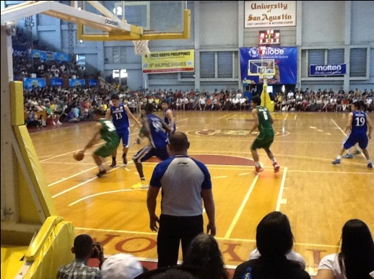

The USASC has actively participated in the UNIGAMES, a national sports event hosted by the university, by organizing and mobilizing more than a hundred volunteer to man for ‘one week’ the various ticketing area locations such as the Iloilo Sports Complex, Iloilo Doctor’s College, Central Philippine University campus, University of San Agustin main and Sambag campus, etc. The USASC also assisted in the billeting of athletes and in the opening ceremony. (The event was featured in various local and national tri-media groups)

***

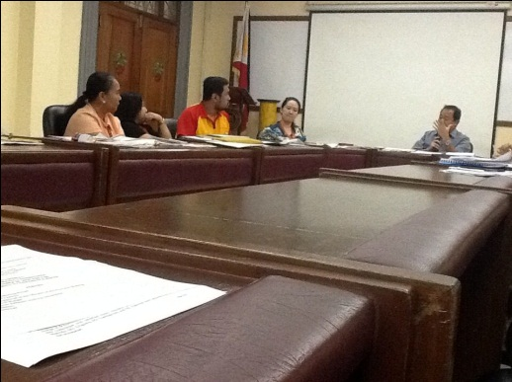

Participated in the 49th ILOILO PRISAA, hosted by the university. The USASC was appointed to head the Awards and Recognition Committee and make I.Ds for the student volunteers of the said event.
(The event was featured in various local tri-media groups)

CULTURE AND THE ARTS

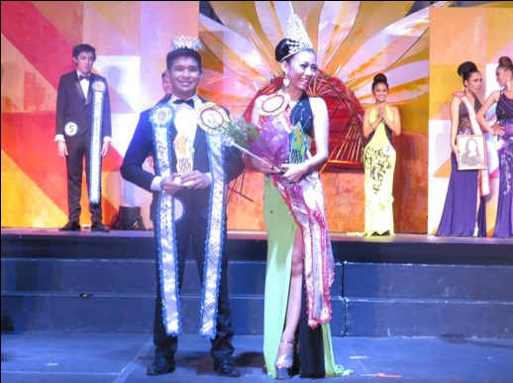

The USASC organized, financed, and facilitated the Mr. and Ms. USA: A Clash of Beauty and Advocacy last University Week. The said competition showcased the Augustinian beauty, brains, talents, and special advocacies of every College and department inside the university. The event consisted of a pre-pageant show held at the USA Auditorium and the grand-pageant night at the USA Gymnasium. In addition to this, the incumbent USASC also financed the implementation of advocacy of the previous Mr. and Ms. Champion i.e. the Basic Education Department.
(The event was featured in various local tri-media groups)

***
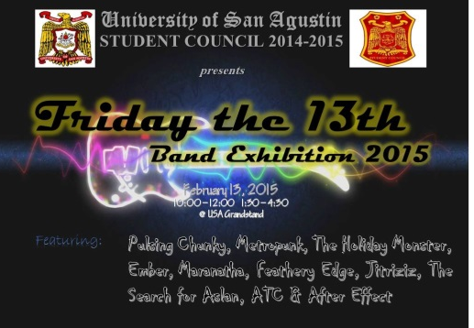

Organized and financed the exhibition of ten band groups held at the USA Grand Stand last University Week. Almost all the invited band groups that performed came from various organizations outside school – except for the CPMT band group that performed.

***

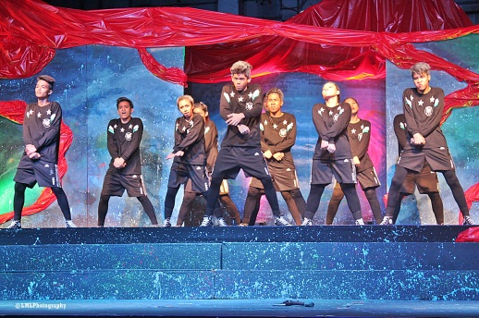

Organized and financed the “Futuristic” Dance Crew 2015 at the USA Gymnasium during the university week celebration. The said event was a showcase of Augustinian talents through epic dance move exhibitions which was participated by various dance groups of every department in the university
(The event was featured in various local and national tri-media groups)

***

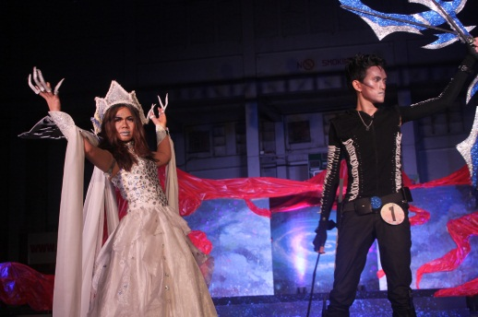

Organized and financed the 2015 T.G.I.F. Galactic competition held at the USA Gymnasium. Side-by-side with the USA’s Best Dance crew, T.G.I.F. showcased the Augustinian creativity, beauty, and talents in modeling through a series of fashion entourage with an out of this world themes varying from intergalactic, extraterrestrial, planet gods and goddesses, as well as constellation or “Led embedded” fashion wears. The USASC also introduced, for the first time, a non-competition category where faculty members will represent their respective departments in the T.G.I.F. runway. (The event was featured in various local and national tri-media groups)

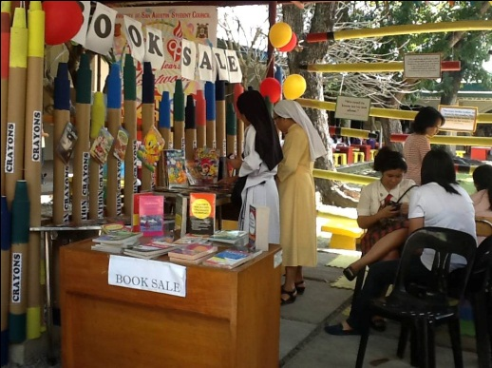
The USASC organized and financed the Student booth competition last University Week to provide an income generating activity for the College councils and some recognized student organizations. Held at the canope area near the USA quadrangle, the participating organizations was able to offer products and services such as face painting, Valentine’s day promos, and other income generating activities.

***

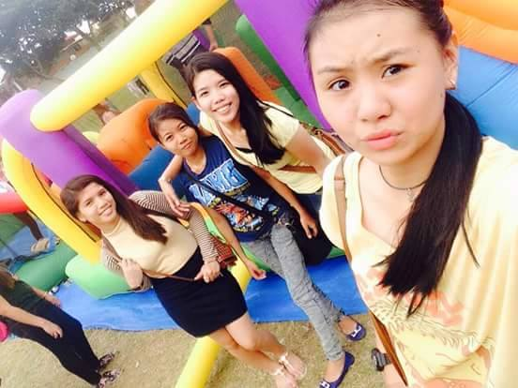

Initiated and financed the Balloon Playground display during the university week celebration at the football field area. The balloon display was provided by the USASC so the little siblings, sons, or daughters of the Augustinian community will also enjoy the university week events in school.

***

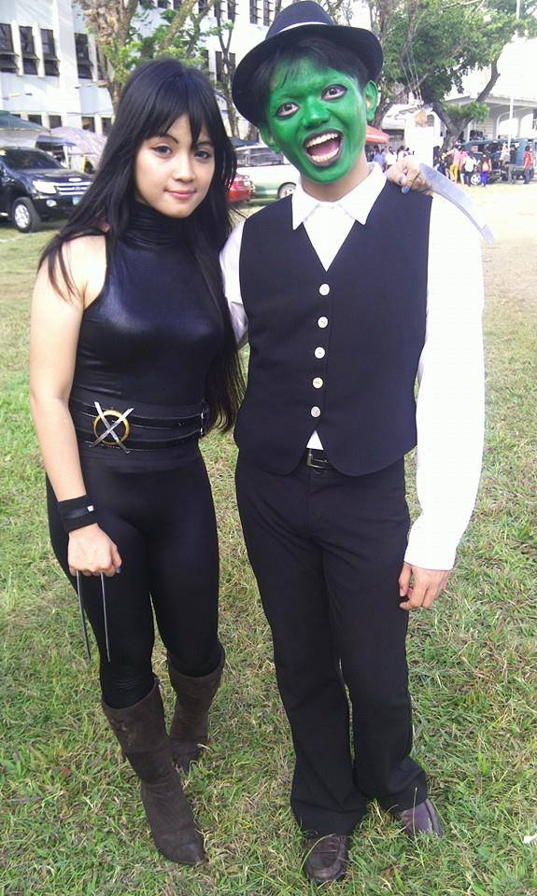
Invited various cosplayers during the University Week to encourage the students to attend the next USASC activity prepared at the USA Grandstand i.e. the Band exhibition.

***

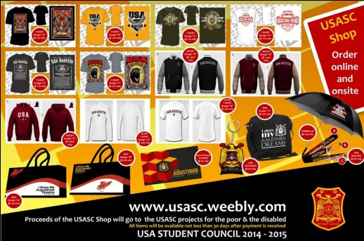

Initiated and financed the USASC Shop to promote the university. Items included were university t-shirts, jackets, bags, ballers, key chains, planners, etc. all the designs were inspired by the “i share my Augustinian dreams” campaign of the USA Student Council.

***
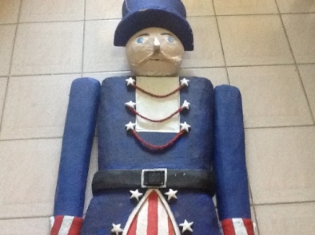

In partnership with PUBUKAD student organization, the USASC initiated and financed the “Nut-craker” decorations at the side gates during the Christmas Party celebration.

***

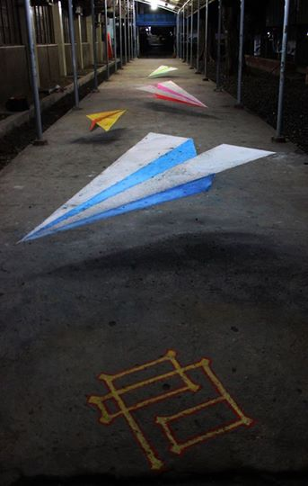

In partnership with the University of San Agustin Fine Arts (Kinno, Kat, Tope, Jester, Ronnyl, & Riche) or the FAMO organization, the USASC facilitated and financed the first 3D ground chalk art in San Agustin during the Pang-abiabi 2014. This was made as part of the welcoming program of the University of San Agustin to its freshmen students.

***

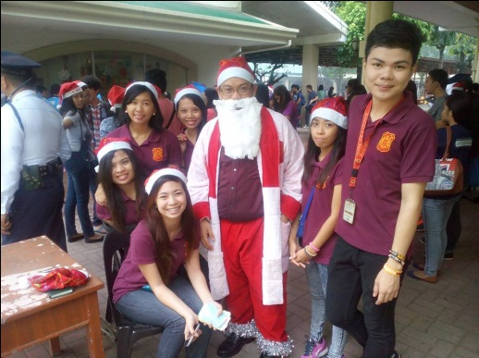

Facilitated the first university wide Christmas party celebration through the Santa Parade which consisted of an invited lyre band guests from other schools and the parade of various student college council officers of every department. During the said parade, thousands of USASC freebies were given away for free!

***

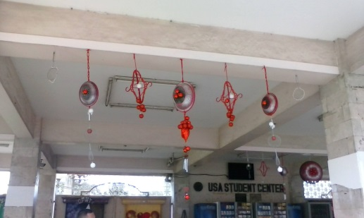

Initiated and financed the decoration of the Alumni Hall during the university wide Christmas Party celebration. The USASC also facilitated a Movie marathon in the same venue.

***

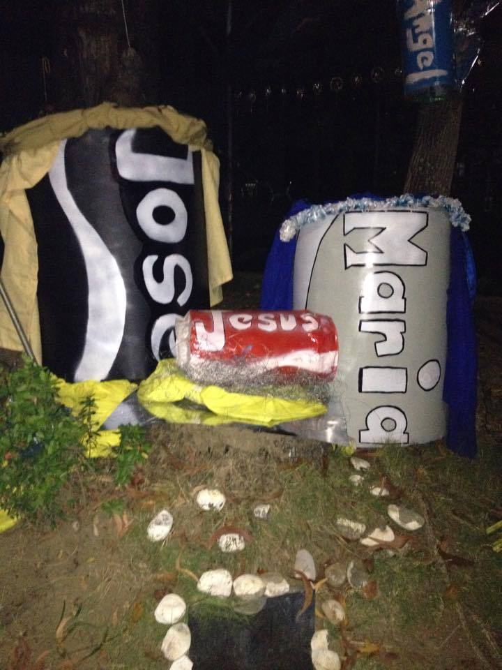

Initiated and facilitated the Belen Making contest during the Christmas party celebration. This is in response to the call of Pope Benedict XVI to restore the annual tradition of putting-up “Belens” during the Christmas season so we can meditate on the life of the Holy family. During the said competition, the USASC allowed the college councils to spice up their belens by predominantly using only one type of material e.g. metal, Styrofoam, glass, plastic, indigenous material, and textiles.

***
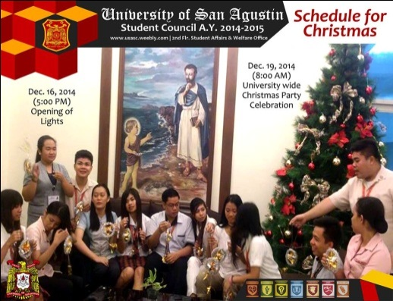

In partnership with the Augustinian TV, the USASC initiated and financed the production of an AVP dubbed “Augustinian Christmas greetings”. The said project involved the student, faculty, and staff of various departments in the university by recording their Christmas greetings to the Augustinian community.

***

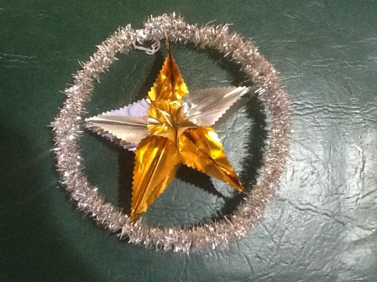

Initiated, conceptualized, and financed thousands of gold and silver Christmas lantern decoration all over the university. The said custom-made lanterns were procured by the USASC as an outreach project to extend help to some Pacubas personnel who hand-made, supplied, and installed the said lanterns.

***

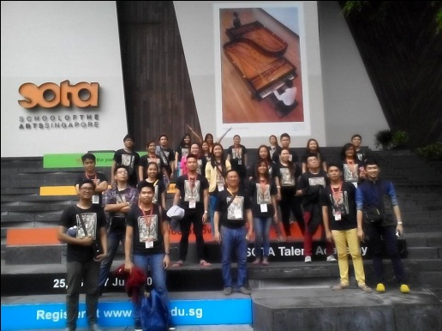

Our USA Troubadours won three gold medals! Two Category Winners! They are also the Category Winner in the Mixed Category and in the Chamber Category. The USA Student Council is a proud sponsor of the t-shirts which they wore during their trip at Singapore.
(The event was featured in various local, national, and international tri-media groups)

***
Tasked by the Student Affairs and Welfare office, the USASC designed the seven (7) official advocacies, the 110th Year Anniversary logo of the University of San Agustin, as well as the design of the Patron Saint’s Week and University Week General schedule tarpaulins.

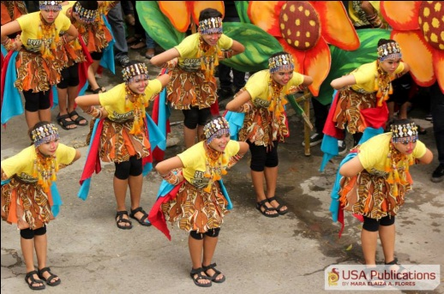

Facilitated and sponsored the annual Sad-sad Competition during the Patron Saint’s day celebration. The sad-sad this year was hailed by many students, faculty, staff, and admin personnel as the best and the grandest sad-sad exhibition in the history of San Agustin. Aside from the very competitive efforts of the College councils and their participants, the USASC also extended monetary assistance (through subsidies) to financially challenged departments – so they too can compete with the bigger departments during the said competition.

***

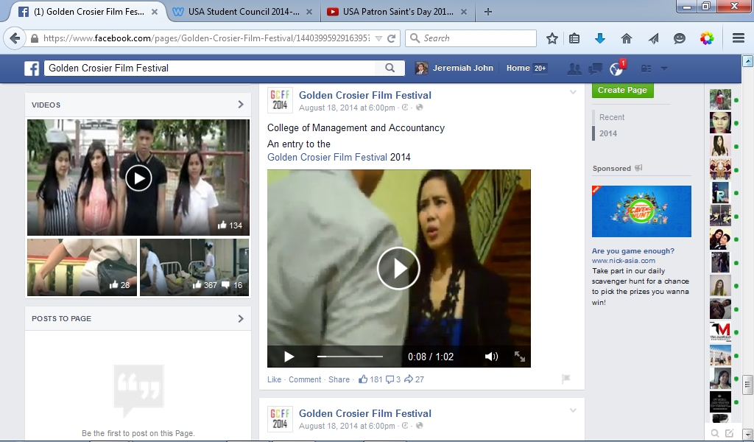

Facilitated the Golden Crossier Film Festival held at various venues within the campus. The said competition showcased short stories about this year’s theme i.e. CARITAS, which refers to the love of God and love of neighbor.

***

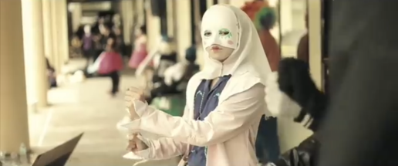

Facilitated and Sponsored the Street Pantomime contest. The idea of the said contest is to entertain the spectators through creative gestures only. That is to say that the participants cannot entertain people using words or noise. The pantomime contest was also an income generating activity aimed to fund the various Augustinian Passion Projects of the college councils.

***

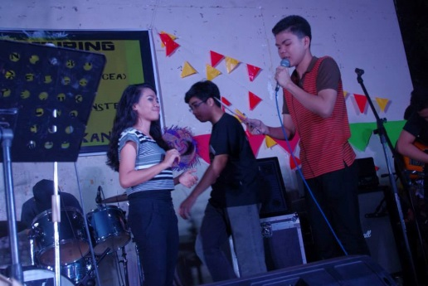

Initiated and sponsored the university wide Barrio Fiesta and Band exhibition dubbed August Rush which was participated by various college departments and outside band guests who all performed at the USA Outside courts last August 29, 2014 after the PSD awards night.

***
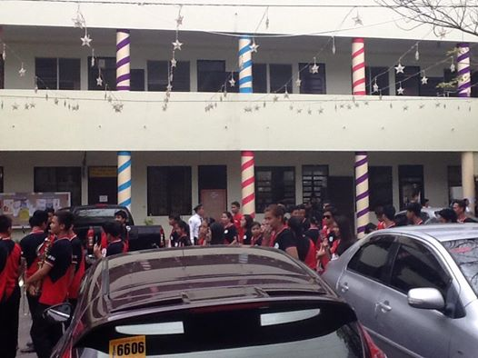
Initiated, conceptualized, and financed the festive drapes that were decorated at the side gates during the Patron Saint’s day celebration. During Christmas celebration, the said drapes were re-used to decorate the Gamboa building so the pillars will look like giant candy canes. This was recycled for the 3rd time during the university week celebration because the shredded textiles were further enhanced to serve as colorful flags that surrounded the perimeter wall of the university.

***

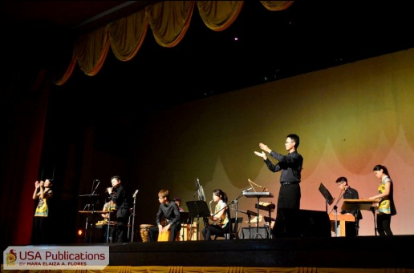

The USASC also extended assistance to the USA External and Alumni Relations Office by ushering in the Organic Resonance concert held last August 8, 2014 at the USA Auditorium.

***

******************************

Committee appointments of the USA Student Council President:

- Committee on Decorum Under R.A. 7877 (Anti-Sexual Harrasment Act of 1995)

- Committee on Student Development Assistance

- Committee on Institutional Marketing and Promotions

- Committee on Libraries and Instructional Media

- Committee on Waste Management

******************************
PHOTO CREDITS BY:
Rev. Fr. Jack Luna OSA, the USA Student Council (Mr. Sunny Lasala, Anne Catherine Malazarte, Jeremiah John Vardeleon, Choilyn Au, and Johnroy Sembrano), In Deum Group (Lian Tesoro and JC Catequista), USA Publications (Mary Johsyen Pabalinas), Club of Augustinian Photographers (Tim Maguad), USAGIASA, Augustinian TV (Bibiana Uzoigwe), The Ledger Publications (Ivan Duran), USA Campus Ministry (Mr. Mark Macaranas), Youth United for the Pope (Fr. Emmanuel Esgerra, Sir Paul Argamosa, John Conrad Carlos, Helicam Philippines, Google.com,
THIS DOCUMENT IS PREPARED BY THE USA STUDENT COUNCIL A.Y. 2014 – 2015

REVIEWED BY:
JEREMIAH JOHN P. VARDELEON

